International Business Major: Technical Knowledge
Direct, Summative Measure: Strategic Management Final Case
Rubric: Strategic Management Final Case Rubric
Criteria for Success: Mean of 3.0 or better
Student Learning Outcome: Mean of 3.3

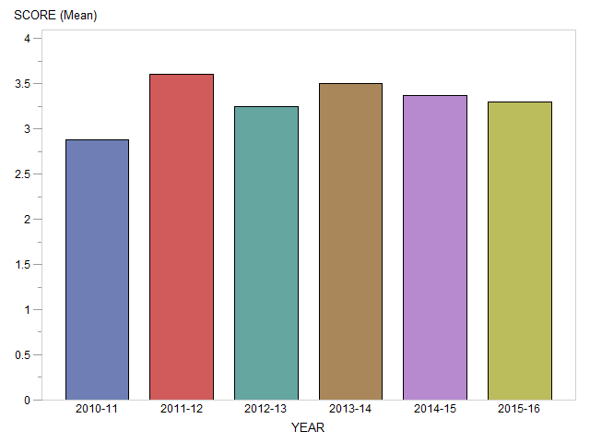

Generated on March 20, 2017

International Business Major: Oral and Written Communication
Direct, Summative Measure: Strategic Management Final Case
Rubric: Strategic Management Final Case Rubric
Criteria for Success: Mean of 3.0 or better
Student Learning Outcome: Mean of 3.25

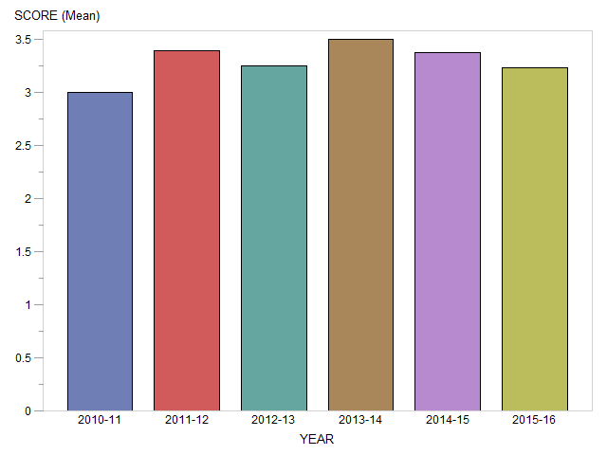

Generated on March 20, 2017

International Business Major: Teamwork
Direct, Summative Measure: Strategic Management Final Case
Rubric: Senior Paper Team Skills Rubric
Criteria for Success: Mean of 3.0 or better
Student Learning Outcome: Mean of 3.8

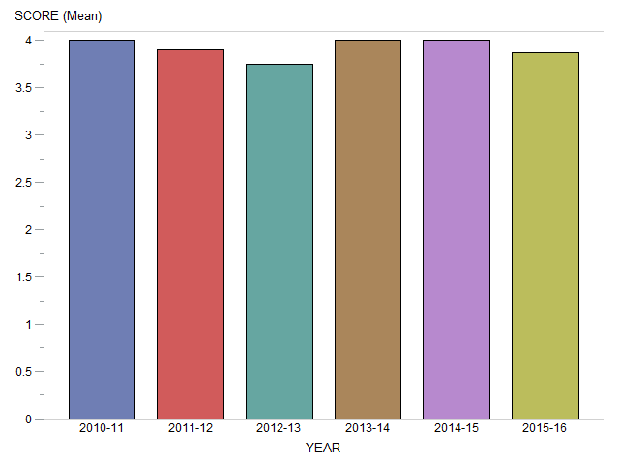

Generated on March 20, 2017

International Business Major: Global Perspectives
Direct, Summative Measure: Strategic Management Final Case
Rubric: Strategic Management Final Case Rubric
Criteria for Success: Mean of 3.0 or better
Student Learning Outcome: Mean of 3.3

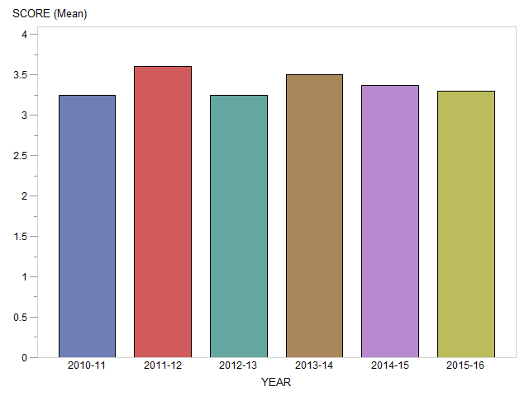

Generated on March 20, 2017

International Business Major: Professionalism
Direct, Summative Measure: Strategic Management Final Case
Rubric: Strategic Management Final Case Rubric
Criteria for Success: Mean of 3.0 or better
Student Learning Outcome: Mean of 3.2

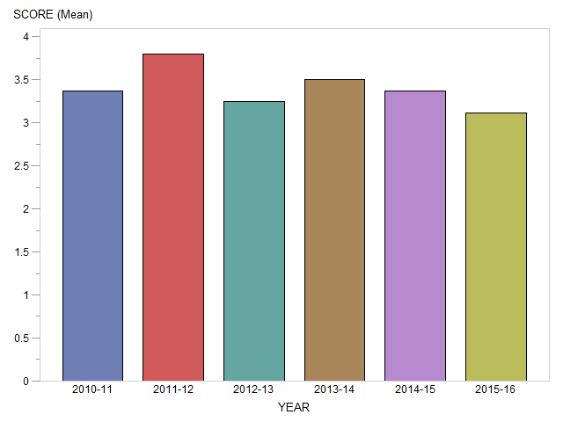

Generated on March 20, 2017

International Business Major: Critical Thinking
Direct, Summative Measure: Strategic Management Final Case
Rubric: Strategic Management Final Case Rubric
Criteria for Success: Mean of 3.0 or better
Student Learning Outcome: Mean of 3.3

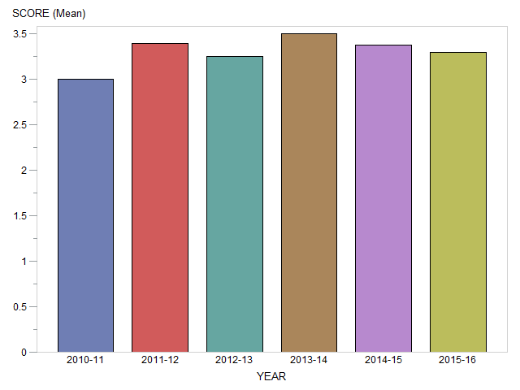

Generated on March 20, 2017

International Business Major: Problem Solving
Direct, Summative Measure: Strategic Management Final Case
Rubric: Strategic Management Final Case Rubric
Criteria for Success: Mean of 3.0 or better
Student Learning Outcome: Mean of 3.3

Generated on March 20, 2017

International Business Major: Information Literacy
Direct, Summative Measure: Strategic Management Final Case
Rubric: Strategic Management Final Case Rubric
Criteria for Success: Mean of 3.0 or better
Student Learning Outcome: Mean of 3.3

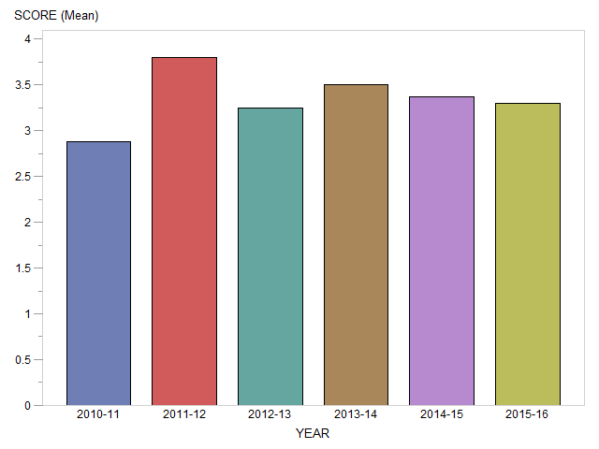

Generated on March 20, 2017

