Finance Major: Technical Knowledge
Direct, Summative Measure: Strategic Management Final Case
Rubric: Strategic Management Final Case Rubric
Criteria for Success: Mean of 3.0 or better
Student Learning Outcome: Mean of 3.75

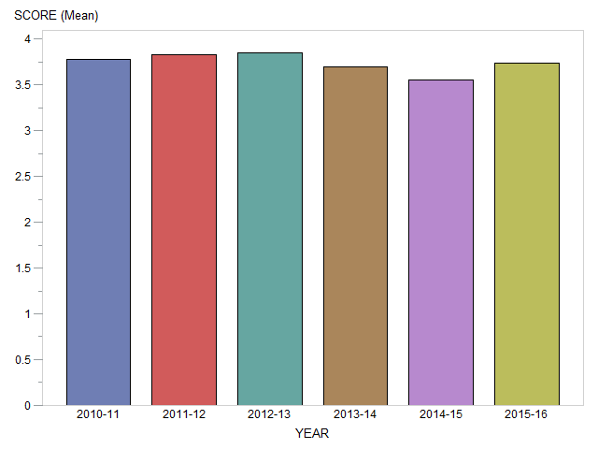

Generated on March 20, 2017

Finance Major: Oral and Written Communication
Direct, Summative Measure: Strategic Management Final Case
Rubric: Strategic Management Final Case Rubric
Criteria for Success: Mean of 3.0 or better
Student Learning Outcome: Mean of 3.75

Generated on March 20, 2017

Finance Major: Teamwork
Direct, Summative Measure: Strategic Management Final Case
Rubric: Senior Paper Team Skills Rubric
Criteria for Success: Mean of 3.0 or better
Student Learning Outcome: Mean of 4.0

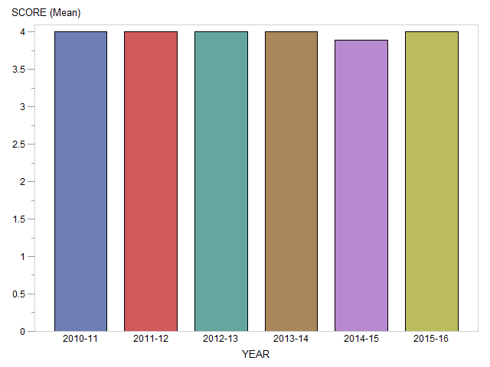

Generated on March 20, 2017

Finance Major: Global Perspectives
Direct, Summative Measure: Strategic Management Final Case
Rubric: Strategic Management Final Case Rubric
Criteria for Success: Mean of 3.0 or better
Student Learning Outcome: Mean of 3.75

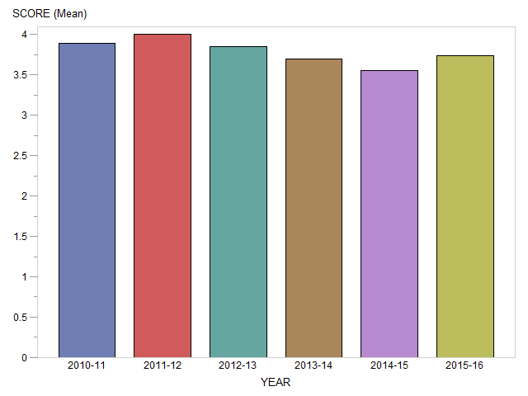

Generated on March 20, 2017

Finance Major: Professionalism
Direct, Summative Measure: Strategic Management Final Case
Rubric: Strategic Management Final Case Rubric
Criteria for Success: Mean of 3.0 or better
Student Learning Outcome: Mean of 3.75

Generated on March 20, 2017

Finance Major: Critical Thinking
Direct, Summative Measure: Strategic Management Final Case
Rubric: Strategic Management Final Case Rubric
Criteria for Success: Mean of 3.0 or better
Student Learning Outcome: Mean of 3.76

Generated on March 20, 2017

Finance Major: Problem Solving
Direct, Summative Measure: Strategic Management Final Case
Rubric: Strategic Management Final Case Rubric
Criteria for Success: Mean of 3.0 or better
Student Learning Outcome: Mean of 3.76

Generated on March 20, 2017

Finance Major: Information Literacy
Direct, Summative Measure: Strategic Management Final Case
Rubric: Strategic Management Final Case Rubric
Criteria for Success: Mean of 3.0 or better
Student Learning Outcome: Mean of 3.77

Generated on March 20, 2017

