Accounting Major: Technical Knowledge
Direct, Summative Measure: Strategic Management Final Case
Rubric: Strategic Management Final Case Rubric
Criteria for Success: Mean of 3.0 or better
Student Learning Outcome: Mean of 3.7

Generated on March 20, 2017

Accounting Major: Oral and Written Communication
Direct, Summative Measure: Strategic Management Final Case
Rubric: Strategic Management Final Case Rubric
Criteria for Success: Mean of 3.0 or better
Student Learning Outcome: Mean of 3.7

Generated on March 20, 2017

Accounting Major: Teamwork
Direct, Summative Measure: Strategic Management Final Case
Rubric: Senior Paper Team Skills Rubric
Criteria for Success: Mean of 3.0 or better
Student Learning Outcome: Mean of 3.9

Generated on March 20, 2017
Accounting Major: Global Perspectives
Direct, Summative Measure: Strategic Management Final Case
Rubric: Strategic Management Final Case Rubric
Criteria for Success: Mean of 3.0 or better
Student Learning Outcome: Mean of 3.73

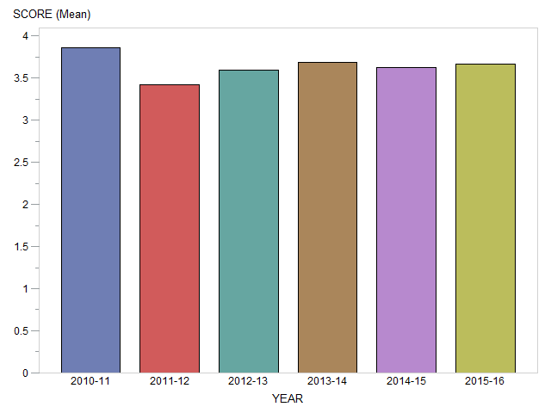

Generated on March 20, 2017

Accounting Major: Professionalism
Direct, Summative Measure: Strategic Management Final Case
Rubric: Strategic Management Final Case Rubric
Criteria for Success: Mean of 3.0 or better
Student Learning Outcome: Mean of 3.7

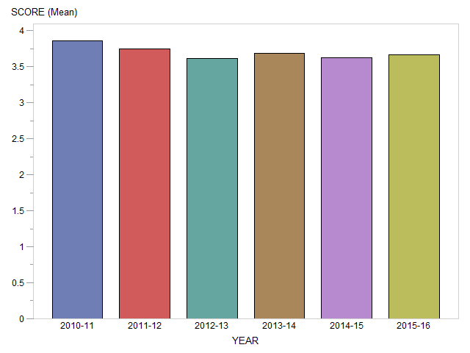

Generated on March 20, 2017

Accounting Major: Critical Thinking
Direct, Summative Measure: Strategic Management Final Case
Rubric: Strategic Management Final Case Rubric
Criteria for Success: Mean of 3.0 or better
Student Learning Outcome: Mean of 3.65

Generated on March 20, 2017

Accounting Major: Problem Solving
Direct, Summative Measure: Strategic Management Final Case
Rubric: Strategic Management Final Case Rubric
Criteria for Success: Mean of 3.0 or better
Student Learning Outcome: Mean of 3.7

Generated on March 20, 2017

Accounting Major: Information Literacy
Direct, Summative Measure: Strategic Management Final Case
Rubric: Strategic Management Final Case Rubric
Criteria for Success: Mean of 3.0 or better
Student Learning Outcome: Mean of 3.8

Generated on March 20, 2017

