Business Administration Major: Technical Knowledge
Direct, Summative Measure: Strategic Management Final Case
Rubric: Strategic Management Final Case Rubric
Criteria for Success: Mean of 3.0 or better
Student Learning Outcome: Mean of 3.4

Generated on March 20, 2017

Business Administration Major: Oral and Written Communication
Direct, Summative Measure: Strategic Management Final Case
Rubric: Strategic Management Final Case Rubric
Criteria for Success: Mean of 3.0 or better
Student Learning Outcome: Mean of 3.25

Generated on March 20, 2017

Business Administration Major: Teamwork
Direct, Summative Measure: Strategic Management Final Case
Rubric: Senior Paper Teams Skills Rubric
Criteria for Success: Mean of 3.0 or better
Student Learning Outcome: Mean of 4.0

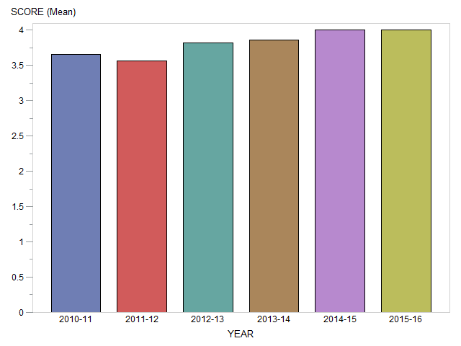

Generated on March 20, 2017

Business Administration Major: Global Perspectives
Direct, Summative Measure: Strategic Management Final Case
Rubric: Strategic Management Final Case Rubric
Criteria for Success: Mean of 3.0 or better
Student Learning Outcome: Mean of 3.4

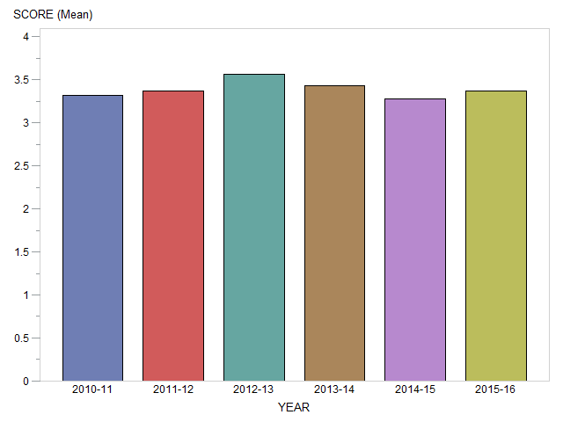

Generated on March 20, 2017

Business Administration Major: Professionalism
Direct, Summative Measure: Strategic Management Final Case
Rubric: Strategic Management Final Case Rubric
Criteria for Success: Mean of 3.0 or better
Student Learning Outcome: Mean of 3.4

Generated on March 20, 2017

Business Administration Major: Critical Thinking
Direct, Summative Measure: Strategic Management Final Case
Rubric: Strategic Management Final Case Rubric
Criteria for Success: Mean of 3.0 or better
Student Learning Outcome: Mean of 3.4

Generated on March 20, 2017

Business Administration Major: Problem Solving
Direct, Summative Measure: Strategic Management Final Case
Rubric: Strategic Management Final Case Rubric
Criteria for Success: Mean of 3.0 or better
Student Learning Outcome: Mean of 3.4

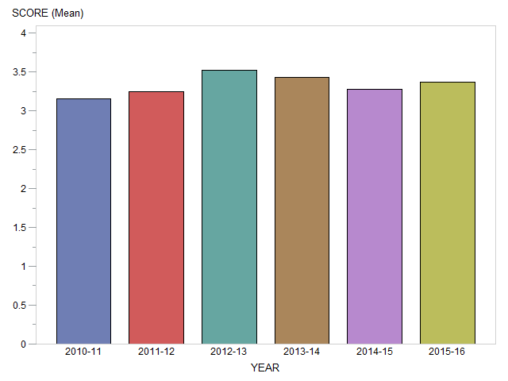

Generated on March 20, 2017

Business Administration Major: Information Literacy
Direct, Summative Measure: Strategic Management Final Case
Rubric: Strategic Management Final Case Rubric
Criteria for Success: Mean of 3.0 or better
Student Learning Outcome: Mean of 3.4

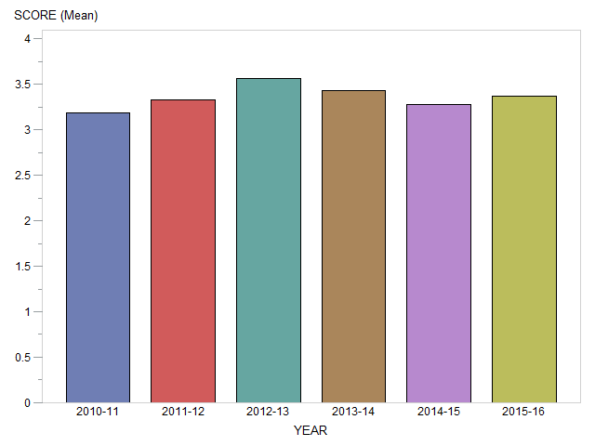

Generated on March 20, 2017

